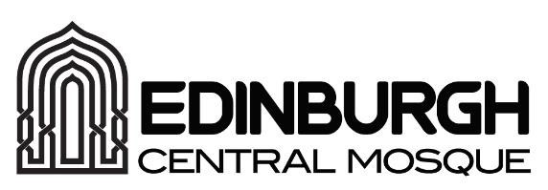
The Mosque of the Custodian of the Two Holy Mosques and Islamic Centre of Edinburgh

Job Vacancy Imam

Role Purpose
- Provide Islamic religious guidance, practices, and leadership to the Muslim community at Edinburgh Central Mosque in accordance with the teachings of the Holy Quran and the Sunnah of Prophet Mohammad (peace and blessings be upon him).
- Establish and promote educational and extracurricular programs for adults and youth
- Lead the establishment of a unified Muslim community, fostering unity and a sense of inclusion among all community members from all backgrounds and cultures.

Responsibilities
- Give the Khutbah and lead prayer for Jumu’ah and Eid Prayers.
- Lead the five daily prayers with assistance from volunteer Imams.
- Provide funeral services and guidance.
- Conduct matrimonial services.
- Maintain regular and convenient office hours at the Mosque for community members to seek religious counsel and guidance.
- Offer Islamic family and youth counselling and guidance as needed.
- Provide Hadith studies, Seerah and Fiqh lessons, and other Islamic topics to increase knowledge and enhance the spiritual growth of community members.
- Teach recitation of Quran according to the differing qiraat.
- Participate in the community activities that further good interfaith and public relations for Islam and Muslims.
- Develop and implement educational and extracurricular programs for both youth and adults.
- Develop annual plans for religious and educational programs at the mosque and present to the Executive Director.
- Lead by example to prevent discrimination on any basis including but not limited to school of thought, gender, race, nationality, ethnic origin, citizenship, political affiliation, or economic status.
- Welcome and host a broad range of groups that visit the mosque to learn about Islam and Muslim community when and as needed.
- Design and manage educational and social programs for New Reverts (Converts).
- Conduct oneself in a manner that is respectful of the history and diversity of the Muslim community.
- Interact with all persons and organizations, Muslim and Non-Muslim, in a manner that reflects positively on the Mosque.
- Provide consultation to the Executive Director on religious matters, community issues, and Mosque activities as requested.
- Other duties as assigned by line manager or executive director

Person Specification/Requirements
- A degree in Islamic Studies or related field from an accredited educational institution.
- Hafiz of Quran, with ability to recite in multiple qiraat.
- Fluency in English and Arabic (spoken and written) is required, fluency in other languages such as Urdu desirable.
- Comprehensive knowledge of Islamic Shariah, and must be familiar with various schools of fiqh and have an awareness of the heritage of different Muslim cultures and background.
- Previous experience as an Imam is required.
- Previous experience in dawah/advocating Islam to varied audiences
- Previous experience in interfaith relations
- Ability to interact with and relate to youth.
- Ability to work with people of different cultures and backgrounds.
- Ability to teach.
- Basic Computing/IT skills i.e use of MS Office & Outlook email, photocopying & printing etc
- Demonstrated experience in conflict prevention and resolution.
- Demonstrated experience in Islamic family and youth counselling.
- Has a dynamic personality and must have qualities such as patience, compassion, humility, tenacity, good character, communication skills and time consciousness.
- Experience in speaking with Non-Muslims about Islam.
Hours and Days of Work:
Employment is on a full-time basis at 37 hours per week Monday – Sunday. Due to the nature of the role, working evenings and/or weekends will be required sometimes throughout the year to ensure continued operations of the organisation and coverage of all religious programs such as 5 daily prayers.
Interested applicants should fill the attached application form and send it along with an updated CV including relevant employment and educational background, in addition to contact details of two references to jobs@edmosque.org

3 weeks until 21st of October.

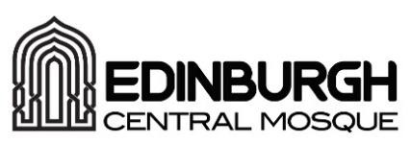

Job/Employment Application Form
You are required to submit an updated CV in addition to this application form.
Post/Role you are applying for
Title
Surname
Initials
Home Address
Postcode
Home Number
Mobile Number
Email Address
Date of Birth
Do you hold a full driving licence?

Education/Qualifications
Qualification Type | Subject | Grade | Date

Relevant Experience: Please refer to the person specification. Continue on a separate sheet of paper if required.

Training and Development
Please use the space below to give information on any training or additional qualifications you have completed, which is relevant to the post you have applied for.
Training Course | Course Details (including length of course, qualification attained and subjects studied)

Additional Supporting Information

References
Please give the details of two references
Name
Address
Phone Number
Email
Occupation
Relationship to the candidate

Name
Address
Phone Number
Email
Occupation
Relationship to the candidate

I confirm that to the best of my knowledge, the information on this application form is correct.
Signature | Print Name | Date

You are required to submit an updated CV in addition to this application form. We cannot consider applications that do not contain both a completed application form and an updated CV.
Please email your completed applications to jobs@edmosque.org or hand in to the main office G008 on the ground floor.

